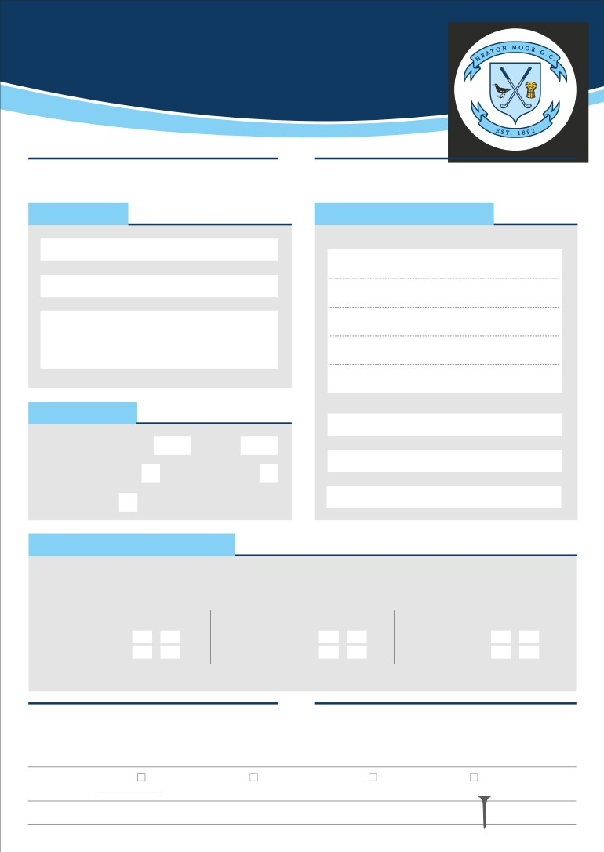

SOCIETY

BOOKING FORM

1. Secure a provisional booking by telephoning the Office or   
 the Professional on 0161 432 2134

ABOUT YOU

Name of Organiser

Society/Company Name

Day & Date Required

GOLF DETAILS

Preferred Start Time Morning Afternoon

Expected Number of Golfers Number of Holes to play

Format *(2,3 or 4 ball)*

GREEN FEES *(all fees include insurance)*

2. Complete the details below and pay your deposit and return  
 to the Office, within 2 weeks by BACS transfer to HMGC LTD, Sort Code 20-82-14 Account No 53256898

CONTACT INFORMATION

Correspondence Address

Postcode:

Telephone Number 1

Telephone Number 2

Email

All prices include: • Nearest the pin’ and ‘longest drive’ competition markers if required

• A large range of prizes available in our golf shop *(presentation table available on request)*

• Free use of practice facilities including putting green, pitching green and practice bunker

MON – WED

18 holes

27 holes

Summer Winter   
 Apr - Sep Oct – Mar

£25. £20

£30. £25

THURS - FRIDAY

18 holes

27 holes

Summer Winter   
Apr - Sep Oct – Mar

£25 £20

£30 £25

WEEKEND

18 holes

27 holes

Summer Winter   
Apr - Sep Oct – Mar

£30 £25

£35 £30

Minimum 12 people - prices per person

DRESS CODE

We have a dress code for both the golf course and the clubhouse. The basic rule on the course is smart traditional golf wear. Spikes are not allowed in the Clubhouse.

COURSE RULES

Please advise your members to observe general golf etiquette   
especially avoiding slow play (e.g. keep up with the game in

front, not just ahead of the game behind). All players must be in possession of their own set of clubs.

Office Use: Receipt Issued Copy to: Professional Catering Manager Steward

Date Tel: 432 2134 Option 2 Tel: 432 2134 Option 3 Tel: 432 2134 Option 4

[WWW.HEATONMOORGOLFCLUB.CO.UK](http://www.heatonmoorgolfclub.co.uk/) | INFO@HEATONMOORGOLFCLUB.CO.UK 0161 432 2134

CATERING   
OPTIONS

Under 15 Players 1 choice except (V), 15 to 29 Players 2 choices and 30 and over 3 choices.

CATERING REQUIREMENTS

Arrival from am/pm Number

Lunch from am/pm Number

Dinner from pm Number

Should you have any catering questions

please contact the kitchen on 0161 432 2134 option 3.

ON ARRIVAL or HALFWAY/9 Holes

Bacon Barm & Brew £6

Full English Breakfast £13  
 Sandwiches BLT or cheese ploughman £8.50

With chips or soup £9.00

Numb

2 COURSE MEAL - £15

STARTER

Number



3 COURSE MEAL - £18.00

DESSERT

Number

A1 - Prawn Cocktail

A2 – Soup & Roll

A3 – Pâté with Melba Toast

STARTER OPTION

B1 – Chicken Tikka Curry with Rice

B2 – Vegatable Tikka with Rice (V)

B3 – Beef Bourguignon Pie with Chips

B4 – Cheese Pie with Chips (V)  
B5 – Ham, Egg & Chips

B6 – Sausage & Mash

MAIN OPTION

C1 - Fruit Crumble

C2 – Sticky Toffee Pudding

C3 - Ice Cream Dessert

DESSERT OPTION



We use the information above to allow us to fulfil our contractual obligations to you as a society organiser in administering the event and we keep this data secure in   
accordance with our Privacy Policy. Copies are available from the club office or online at [www.heatonmoorgolfclub.co.uk.](http://www.heatonmoorgolfclub.co.uk./)

We would like to retain your data to enable us to send you information about future offers at the club available to Societies. If you are happy for us to do this please tick this box:

*‘I agree to you retaining my data for this purpose’*

I (BLOCK CAPITALS) confirm the details above as being as

accurate as possible. I have read the Terms and Conditions and accept responsibility for the members of the Society. I enclose a deposit of £100 made payable to HMGC Ltd - SORT CODE 20-82-14 ACCOUNT No 53256898

Signature Date

[WWW.HEATONMOORGOLFCLUB.CO.UK](http://www.heatonmoorgolfclub.co.uk/) | INFO@HEATONMOORGOLFCLUB.CO.UK 0161 432 2134